Project Design Phase
Solution Architecture
Date | 27 June 2025
Team ID | NM2025TMID00021
Project Name | Streamlining Ticket Assignment for Efficient Support Operations
Maximum Marks | 4 Marks

Solution Architecture:
Goals of the Architecture:

- Automate ticket assignment to reduce manual workload.
- Ensure balanced workload distribution among support agents.
- Improve response time and enhance customer satisfaction.
- Maintain transparency, accountability, and SLA compliance in ticket handling.

Key Components:

- Incident Table (records all customer issues and tickets)
- Assignment Rules (logic to determine ticket distribution)
- Flow Designer / Automation Rule (manages ticket routing process)
- Agent Table (stores agent profiles, skills, and workload capacity)
- Dashboard & Analytics Module (tracks ticket flow and agent performance)

Development Phases:

1. Configure support agents and user groups based on expertise.
2. Create and define ticket categories and priority levels.
3. Design and implement the automated assignment logic using Flow Designer.
4. Test auto-assignment across various cases (based on agent availability, skill, and ticket urgency).
5. Validate performance through monitoring dashboards and SLA tracking.

- Solution Architecture Description:

The Streamlining Ticket Assignment for Efficient Support Operations solution architecture is designed to enhance IT support efficiency through automation and intelligent routing. The architecture leverages ServiceNow’s Flow Designer and Assignment Rules to automatically allocate tickets based on pre-defined logic that evaluates ticket category, priority, agent workload, and skill set.

The architecture ensures that every incoming ticket is assigned to the most appropriate agent or group without manual intervention. This reduces response delays, ensures fair workload balance, and minimizes human errors.
Performance analytics and dashboards provide visibility into real-time workloads and help identify operational bottlenecks.By integrating automation and monitoring mechanisms, this architecture supports high system reliability, improved productivity, and better service quality. It significantly reduces administrative effort while ensuring scalability for larger support operations in enterprise environments.

Example-Solution Architecture Diagram:
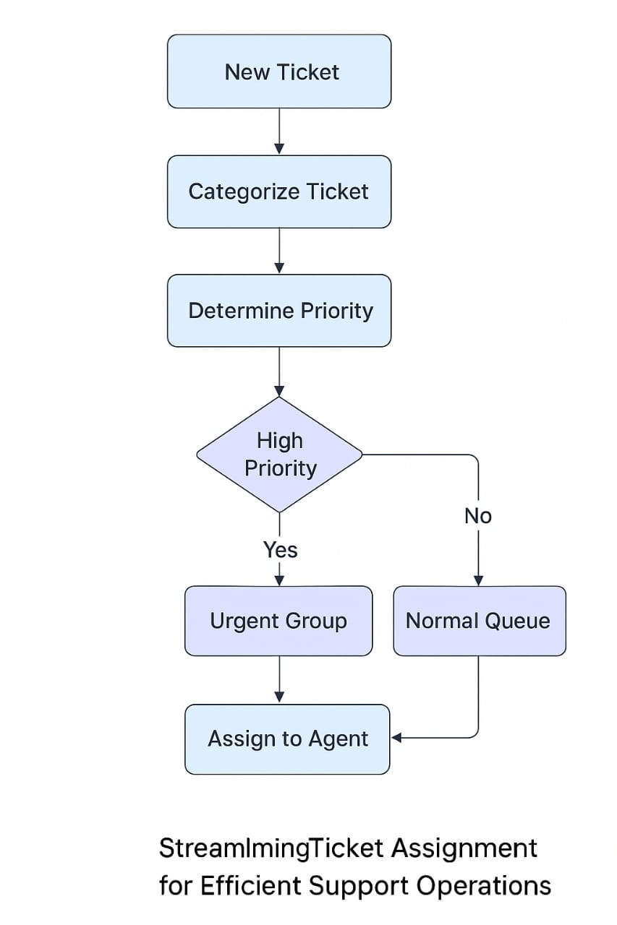
Reference: https://docs.servicenow.com/bundle/tokyo-servicenow-platform/page/administer/flow-designer/concept/flow-designer.html

